**Unit – I**

**DC & AC Circuits**

**1.1 ELECTRICAL CIRCUIT ELEMENTS (R, L & C)**

**1.1.1Resistance Parameter – Ohm’s law**

When a current flows in a material, the free electrons move through the material and collide with other atoms. These collisions cause the electrons to lose some of their energy. This loss of energy per unit charge is the drop in potential across the material. The amount of energy lost by the electrons is related to the physical property of the material. These collisions restrict the movement of electrons. The property of a material to restrict the flow of electrons is called resistance, denoted by R. The symbol for the resistor is shown in Fig. 1.1.



The unit of resistance is ohm (Ω). Ohm is defined as the resistance offered by the material when a current of one ampere flows between two terminals with one volt applied across it. According to Ohm’s law, the current is directly proportional to the voltage and inversely proportional to the total resistance of the circuit, i.e.

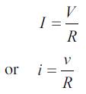

We can write the above equation in terms of charge as follows.

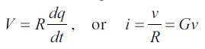

Where G is the conductance of a conductor. The units of resistance and conductance are ohm (Ω) and mho (J) respectively.

When current flows through any resistive material, heat is generated by the collision of electrons with other atomic particles. The power absorbed by the resistor is converted to heat. The power absorbed by the resistor is given by



Where i is the current in the resistor in amps, and v is the voltage across the resistor in volts. Energy lost in a resistance in time t is given by

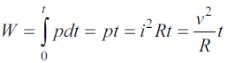

Where v is the volts

R is in ohms

T is in seconds and

W is in joules

**1.1.2 Inductance Parameter**

A wire of certain length, when twisted into a coil becomes a basic inductor. If current is made to pass through an inductor, an electromagnetic field is formed. A change in the magnitude of the current changes the electromagnetic field. Increase in current expands the fields, and decrease in current reduces it. Therefore, a change in current produces change in the electromagnetic field, which induces a voltage across the coil according to Faraday’s law of electromagnetic induction. The unit of inductance is henry, denoted by H. By definition, the inductance is one henry when current through the coil, changing at the rate of one ampere per second, induces one volt across the coil. The symbol for inductance is shown in Fig. 1.2.

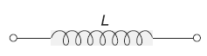

The current-voltage relation is given by

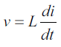

where v is the voltage across inductor in volts, and i is the current through inductor in amps.

We can rewrite the above equations as

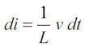

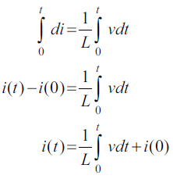

From the above equation we note that the current in an inductor is dependent upon the integral of the voltage across its terminals and the initial current in the coil, i(0). The power absorbed by inductor is



The energy stored by the inductor is

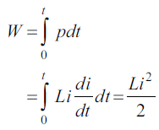

From the above discussion, we can conclude the following.

1. The induced voltage across an inductor is zero if the current through it is constant. That means an inductor acts as short circuit to dc.

2. A small change in current within zero time through an inductor gives an infinite voltage across the inductor, which is physically impossible. In a fixed inductor the current cannot change abruptly.

3. The inductor can store finite amount of energy, even if the voltage across the inductor is zero, and

4. A pure inductor never dissipates energy, only stores it. That is why it is also called a non-dissipative passive element. However, physical inductors dissipate power due to internal resistance.

**1.1.3 Capacitance Parameter**

Any two conducting surfaces separated by an insulating medium exhibit the property of a capacitor. The conducting surfaces are called electrodes, and the insulating medium is called dielectric. A capacitor stores energy in the form of an electric field that is established by the opposite charges on the two electrodes. The electric field is represented by lines of force between the positive and negative charges, and is concentrated within the dielectric. The amount of charge per unit voltage that is capacitor can store is its capacitance, denoted by C. The unit of capacitance is Farad denoted by F. By definition, one Farad is the amount of capacitance when one coulomb of charge is stored with one volt across the plates. The symbol for capacitance is shown in Fig. 1.3.

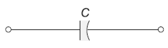

A capacitor is said to have greater capacitance if it can store more charge per unit voltage and the capacitance is given by



We can write the above equation in terms of current as

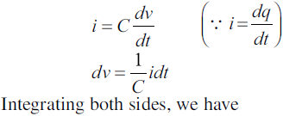

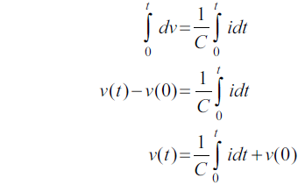

Where v(0) indicates the initial voltage across the capacitor. From the above equation, the voltage in a capacitor is dependent upon the integral of the current through it, and the initial voltage across it.

The power absorbed by the capacitor is given by



The energy stored by the capacitor is

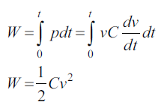

From the above discussion we can conclude the following

1. The current in a capacitor is zero if the voltage across it is constant; that means, the capacitor acts as an open circuit to dc.

2. A small change in voltage across a capacitance within zero time gives an infinite current through the capacitor, which is physically impossible. In a fixed capacitance the voltage cannot change abruptly.

3. The capacitor can store a finite amount of energy, even if the current through it is zero, and

4. A pure capacitor never dissipates energy, but only stores it; that is why it is called non-dissipative passive element. However, physical capacitors dissipate power due to internal resistance.

**1.2 KIRCHHOFF'S LAWS**

**1.2.1 Kirchhoff’s Voltage Law**

Kirchhoff’s voltage law states that the algebraic sum of all branch voltages around any closed path in a circuit is always zero at all instants of time. When the current passes through a resistor, there is a loss of energy and, therefore, a voltage drop. In any element, the current always flows from higher potential to lower potential. Consider the circuit in Fig. 1.50. It is customary to take the direction of current I as indicated in the figure, i.e. it leaves the positive terminal of the voltage source and enters into the negative terminal.

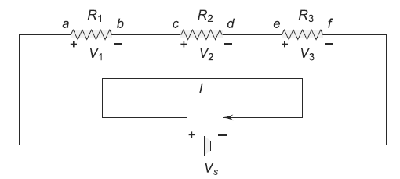

As the current passes through the circuit, the sum of the voltage drop around the loop is equal to the total voltage in that loop. Here the polarities are attributed to the resistors to indicate that the voltages at points a, c and e are more than the voltages at b, d and f, respectively, as the current passes from a to f.



Consider the problem of finding out the current supplied by the source V in the circuit shown in Fig. 1.51.

Our first step is to assume the reference current direction and to indicate the polarities for different elements. (See Fig. 1.52).

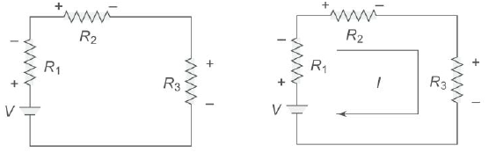

By using Ohm’s law, we find the voltage across each resistor as follows.



Where VR1, VR2 and VR3 are the voltages across R1, R2 and R3, respectively. Finally, by applying Kirchhoff’s law, we can form the equation

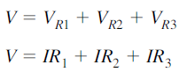

From the above equation the current delivered by the source is given by



**1.2.2 Kirchhoff’s Current Law**

Kirchhoff’s current law states that the sum of the currents entering into any node is equal to the sum of the currents leaving that node. The node may be an interconnection of two or more branches. In any parallel circuit, the node is a junction point of two or more branches. The total current entering into a node is equal to the current leaving that node. For example, consider the circuit shown in Fig. 1.67, which contains two nodes A and B.

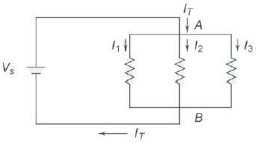

The total current IT entering node A is divided into I1, I2 and I3. These currents flow out of node A. According to Kirchhoff’s current law, the current into node A is equal to the total current out of node A: that is, IT = I1 + I2 + I3. If we consider node B, all three currents I1, I2, I3 are entering B, and the total current IT is leaving node B, Kirchhoff’s current law formula at this node is therefore the same as at node A. I1 + I2 + I3 = IT

In general, sum of the currents entering any point or node or junction equal to sum of the currents leaving from that point or node or junction as shown in Fig. 1.68.

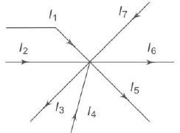

I1 + I2 + I4 + I7 = I3 + I5 + I6

If all of the terms on the right side are brought over to the left side, their signs change to negative and a zero is left on the right side, i.e.

I1 + I2 + I4 + I7 – I3 – I5 – I6 = 0

This means that the algebraic sum of all the currents meeting at a junction is equal to zero.

**1.3 SERIES AND PARALLEL CONNECTION OF RESISTANCES WITH DC EXCITATION**

**1.3.1 Series Resistors & Voltage Division**

The series circuit acts as a voltage divider. Since the same current flows through each resistor, the voltage drops are proportional to the values of resistors. Using this principle, different voltages can be obtained from a single source, called a voltage divider. For example, the voltage across a 40Ω resistor is twice that of 20Ω in a series circuit shown in Fig. 1.58.

In general, if the circuit consists of a number of series resistors, the total current is given by the total voltage divided by equivalent resistance. This is shown in Fig. 1.59.

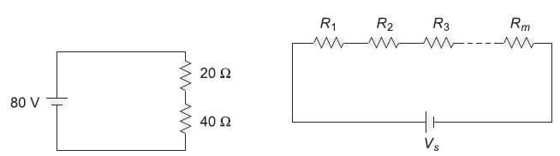

The current in the circuit is given by I = Vs /(R1 + R2 + … + Rm). The voltage across any resistor is nothing but the current passing through it, multiplied by that particular resistor.

Therefore, VR1 = IR1

VR2 = IR2

VR3 = IR3

**.**

**.**

**.**

**.**

VRm = IRm

Or 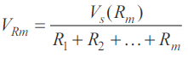

From the above equation, we can say that the voltage drop across any resistor, or a combination of resistors, in a series circuit is equal to the ratio of that resistance value to the total resistance, multiplied by the source voltage, i.e.

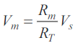

Where Vm is the voltage across mth resistor, Rm is the resistance across which the voltage is to be determined and RT is the total series resistance.

**1.3.2.1 Parallel Resistance**

When the circuit is connected in parallel, the total resistance of the circuit decreases as the number of resistors connected in parallel increases. If we consider m parallel branches in a circuit as shown in Fig. 2.75, the current equation is IT = I1 + I2 + ... + Im

The same voltage is applied across each resistor. By applying Ohm’s law, the current in each branch is given by

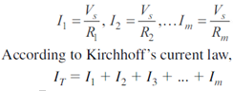

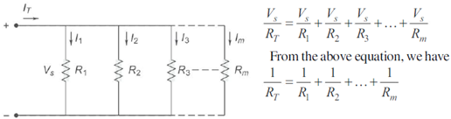

**1.3.2.2 Current Division**

In a parallel circuit, the current divides in all branches. Thus, a parallel circuit acts as a current divider. The total current entering into the parallel branches is divided into the branches currents according to the resistance values. The branch having higher resistance allows lesser current, and the branch with lower resistance allows more current. Let us find the current division in the parallel circuit shown in Fig. 1.78.

The voltage applied across each resistor is Vs. The current passing through each resistor is given by

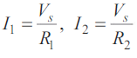

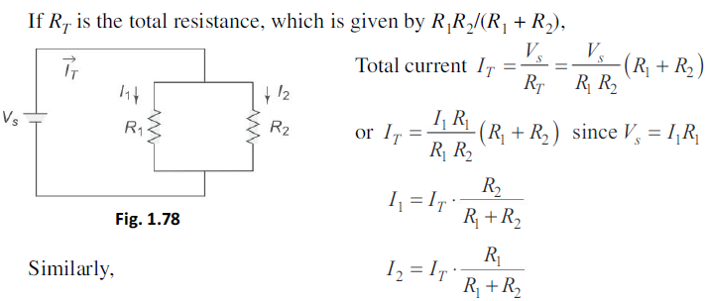

From the above equations, we can conclude that the current in any branch is equal to the ratio of the opposite branch resistance to the total resistance value, multiplied by the total current in the circuit. In general, if the circuit consists of m branches, the current in any branch can be determined by

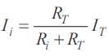

Where, Ii represents the current in the ith branch

Ri is the resistance in the ith branch

RT is the total parallel resistance to the ith branch and

IT is the total current entering the circuit.

**1.4 LOOP AND NODAL METHODS OF ANALYSIS OF NET WORKS**

**1.4.1 Mesh (Loop) Analysis**

Mesh and nodal analysis are two basic important techniques used in finding solutions for a network. The suitability of either mesh or nodal analysis to a particular problem depends mainly on the number of voltage sources or current sources. If a network has a large number of voltage sources, it is useful to use mesh analysis; as this analysis requires that all the sources in a circuit be voltage sources. Therefore, if there are any current sources in a circuit they are to be converted into equivalent voltage sources, if, on the other hand, the network has more current sources, nodal analysis is more useful.

Mesh analysis is applicable only for planar networks. For non-planar circuits mesh analysis is not applicable. A circuit is said to be planar, if it can be drawn on a plane surface without crossovers. A non-planar circuit cannot be drawn on a plane surface without a crossover.

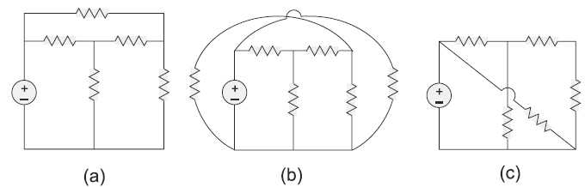

Figure (a) is a planar circuit. Figure 5.112 is a non-planar circuit and Fig. 5.112(c) is a planar circuit which looks like a non-planar circuit. It has already been discussed that a loop is a closed path. A mesh is defined as a loop which does not contain any other loops within it. To apply mesh analysis, our first step is to check whether the circuit is planar or not and the second is to select mesh currents. Finally, writing Kirchhoff’s voltage law equations in terms of unknowns and solving them leads to the final solution.

Observation of the below Figure indicates that there are two loops abefa, and bcdeb in the network. Let us assume loop currents I1 and I2 with directions as indicated in the figure. Considering the loop abefa alone, we observe that current I1 is passing through R1, and (I1 – I2) is passing through R2. By applying Kirchhoff’s voltage law, we can write

Vs = I1R1 + R2 (I1 – I2)

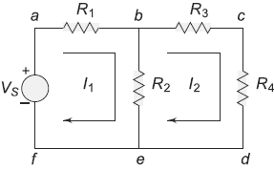

Similarly, if we consider the second mesh bcdeb, the current I2 is passing through R3 and R4, and (I2 – I1) is passing through R2. By applying Kirchhoff’s voltage law around the second mesh, we have

R2 (I2 – I1) + R3 I2 + R4 I2 = 0

By rearranging the above equations, the corresponding mesh current equations are

I1 (R1 + R2) – I2 R2 = Vs

– I1 R2 + (R2 + R3 + R4) I2 = 0

By solving the above equations, we can find the currents I1 and I2. If we observe above Figure, the circuit consists of five branches and four nodes, including the reference node. The number of mesh currents is equal to the number of mesh equations.

And the number of equations = branches – (nodes – 1). In above Figure, the required number of mesh currents would be 5 – (4 – 1) = 2.

In general, if we have B number of branches and N number of nodes including the reference node then the number of linearly independent mesh equations M = B – (N – 1).

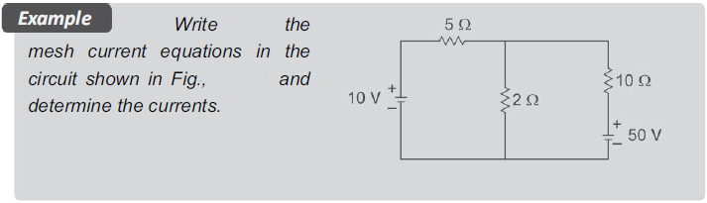

**Solution**:- Assume two mesh currents in the direction as indicated in below Figure.

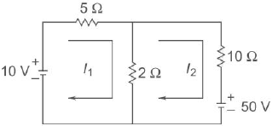

The mesh current equations are

5I1 + 2 (I1 – I2) = 10

10I2 + 2 (I2 – I1) + 50 = 0

We can rearrange the above equations as

7I1 – 2I2 = 10

–2I1 + 12I2 = –50

By solving the above equations, we have

I1 = 0.25 A, and I2 = –4.125 A

Here the current in the second mesh, I2, is negative; that is the actual current I2 flows opposite to the assumed direction of current in the circuit of above figure.

**1.4.2 Nodal Analysis**

To apply, in a N node circuit, one of the nodes is chosen as reference or datum node, then it is possible to write N – 1 nodal equations by assuming N – 1 node voltages. For example, a 10 node circuit requires nine unknown voltages and nine equations. Each node in a circuit can be assigned a number or a letter. The node voltage is the voltage of a given node with respect to one particular node, called the reference node, which we assume at zero potential.

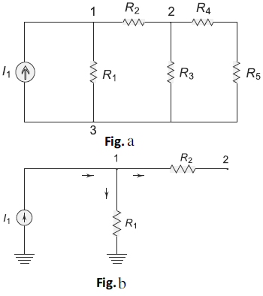

In the circuit shown in Fig. a, node 3 is assumed as the reference node. The voltage at node 1 is the voltage at that node with respect to node 3. Similarly, the voltage at node 2 is the voltage at that node with respect to node 3. Applying Kirchhoff’s current law at node 1; the current entering is equal to the current leaving. (See Fig. b).



Where V1 and V2 are the voltages at node 1 and 2, respectively. Similarly, at node 2, the current entering is equal to the current leaving as shown in Fig. c.

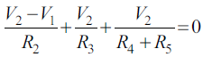

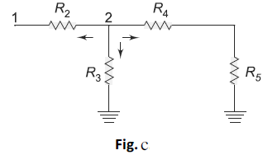

Rearranging the above equations, we have

$$V_{1}\left[\frac{1}{R_{1}}+\frac{1}{R_{2}}\right]-V_{2}\left[\frac{1}{R_{2}}\right]=I_{1}$$

$${-V}_{1}\left[\frac{1}{R_{2}}\right]+V_{2}\left[\frac{1}{R_{2}}+\frac{1}{R_{3}}+\frac{1}{R_{4}+R_{5}}\right]=0$$

From the above equations, we can find the voltages at each node.

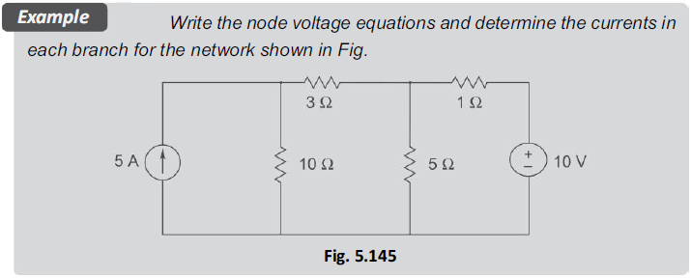

**Solution**:- The first step is to assign voltages at each node as shown in below figure. 5.146.

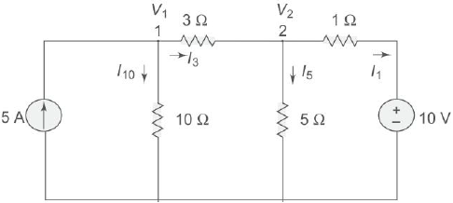

Applying Kirchhoff’s current law at node 1,

we have

$$5=\frac{V_{1}}{10}+\frac{V_{1}-V_{2}}{3}$$

$$V_{1}\left[\frac{1}{10}+\frac{1}{3}\right]-V_{2}\left[\frac{1}{3}\right]=5 (i)$$

Applying Kirchhoff’s current law at node 2,

We have

$$\frac{V_{2}-V_{1}}{3}+\frac{V_{2}}{5}+\frac{V_{2}-10}{1}=0$$

${-V}_{1}\left[\frac{1}{3}\right]-V_{2}\left[\frac{1}{3}+\frac{1}{5}+1\right]=10$ (ii)

From Eqs (i) and (ii), we can solve for V1 and V2 to get

V1 = 19.85 V, V2 = 10.9 V

**1.5 THEVININ’S AND SUPER POSITION THEOREMS**

**1.5.1 SUPERPOSITION THEOREM**

The superposition theorem states that in any linear network containing two or more sources, the response in any element is equal to the algebraic sum of the responses caused by individual sources acting alone, while the other sources are non-operative; that is, while considering the effect of individual sources, other ideal voltage sources and ideal current sources in the network are replaced by short circuit and open circuit across their terminals. This theorem is valid only for linear systems. This theorem can be better understood with a numerical example.

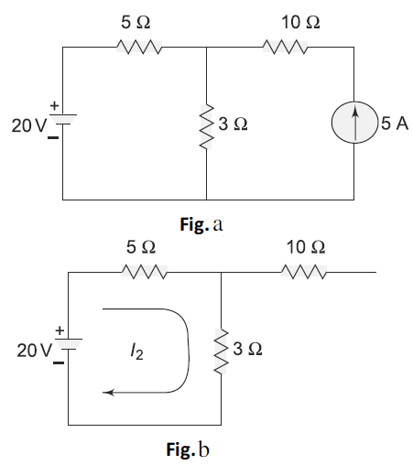

Consider the circuit which contains two sources as shown in Fig. a. Now let us find the current passing through the 3Ω resistor in the circuit. According to superposition theorem, the current I2 due to the 20V voltage source with 5A source open circuited

$$I_{2}=\frac{20}{5+3}=2.5A$$

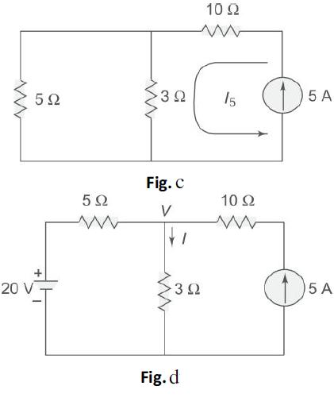

The current I5 due to 5A source with 20V source short circuited is

$$I_{5}=5×\frac{5}{\left(3+5\right)}=3.125A$$

The total current passing through the 3Ω resistor is

(2.5 + 3.125) = 5.625A

Let us verify the above result by applying nodal analysis.

The current passing in the 3Ω resistor due to both sources should be 5.625 A. Applying nodal analysis to Fig. d, we have

$$\frac{V-20}{5}+\frac{V}{3}=5$$

$$V\left[\frac{1}{5}+\frac{1}{3}\right]=5+4$$

$$V=9×\frac{15}{8}=16.875V$$

The current passing through the 3Ω resistor is equal to V/3, i.e.

$$I=\frac{16.875}{3}=5.625A$$

So the superposition theorem is verified.

Let us now examine the power responses.

Power dissipated in the 3Ω resistor due to voltage source acting alone

P20 = (I2)2R = (2.5)2×3 = 18.75W

Power dissipated in the 3Ω resistor due to current source acting alone

P5 = (I5)2

R = (3.125)2×3 = 29.29W

Power dissipated in the 3Ω resistor when both the sources are acting simultaneously is given by

P = (5.625)2×3 = 94.92W

From the above results, the superposition of P20 and P5 gives

P20 + P5 = 48.04W

Which is not equal to P = 94.92W

We can, therefore, state that the superposition theorem is not valid for power responses. It is applicable only for computing voltage and current responses.

**1.5.2 THEVENIN’S THEOREM**

In many practical applications, it is always not necessary to analyze the complete circuit; it requires that the voltage, current, or power in only one resistance of a circuit be found. The use of this theorem provides a simple, equivalent circuit which can be substituted for the original network. Thevenin’s theorem states that any two terminal linear network having a number of voltage current sources and resistances can be replaced by a simple equivalent circuit consisting of a single voltage source in series with a resistance, where the value of the voltage source is equal to the open circuit voltage across the two terminals of the network, and resistance is equal to the equivalent resistance measured between the terminals with all the energy sources are replaced by their internal resistances. According to Thevenin’s theorem, an equivalent circuit can be found to replace the circuit in Fig. a.

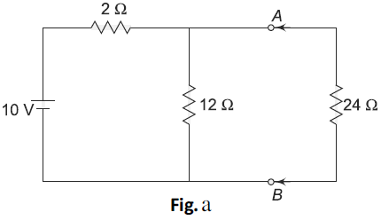

In the circuit, if the load resistance 24Ω is connected to Thevenin’s equivalent circuit, it will have the same current through it and the same voltage across its terminals as it experienced in the original circuit. To verify this, let us find the current passing through the 24Ω resistance due to the original circuit.

$$I_{24}=I_{T}×\frac{12}{12+24};I_{T}=\frac{10}{2+\frac{12}{24}}= \frac{10}{10}=1A$$

$$I_{24}=1×\frac{12}{12+24}=0.33A$$

The voltage across the 24V resistor = 0.33×24 = 7.92V. Now let us find Thevenin’s equivalent circuit.

The Thevenin voltage is equal to the open circuit voltage across the terminals ‘AB’, i.e. the voltage across the 12 V resistor. When the load resistance is disconnected from the circuit, the Thevenin voltage

$$V_{Th}=10×\frac{12}{14}=8.57V$$

The resistance into the open circuit terminals is equal to the Thevenin resistance

$$R_{Th}=\frac{12×2}{14}=1.71Ω$$

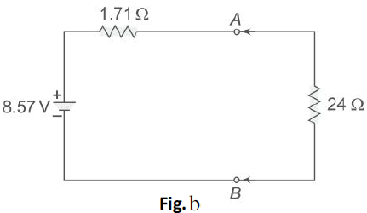

Thevenin’s equivalent circuit is shown in Fig. b. Now let us find the current passing through the 24Ω resistance and voltage across it due to Thevenin’s equivalent circuit.

The voltage across the 24Ω resistance is equal to 7.92 V. Thus, it is proved that $R_{L}(=24Ω)$ has the same values of current and voltage in both the original circuit and Thevenin’s equivalent circuit.